Experiment – 05
Name: MITHULESH J Roll.no: 240701313
Task Analysis – Online Food Ordering System
Task Analysis
Task Analysis is the process of breaking down a user's interaction with an Online Food Ordering System into smaller and manageable steps. It helps to understand how users open the application, browse restaurants, select food items, place orders, make payments, and receive their food.
Task analysis identifies the actions performed by users, system responses, and possible problems during the ordering process.
This analysis helps designers improve the usability, efficiency, and reliability of the food ordering platform.

Key Aspects of Task Analysis
• Understanding the tasks users perform (opening the app, selecting restaurant, ordering food).
• Identifying the sequence of actions needed to complete an order.
• Analyzing user difficulties such as payment failure, delayed delivery, or unavailable food items.
• Defining system requirements to improve ordering experience and delivery efficiency.
• Ensuring smooth ordering, payment processing, and order tracking.

User Flow
User Flow represents the step-by-step process a user follows while ordering food using the system. It visually explains how a user moves through different screens until the order is successfully completed.

User Flow for Online Food Ordering System
Start → Open App → Login/Register → Browse Restaurants → Select Restaurant → View Menu → Select Food Items → Add Items to Cart → Continue Ordering? → Proceed to Checkout → Enter Delivery Address → Choose Payment Method → Payment Confirmation → Order Placed → Track Order → Food Delivered → End

User Flow – Step by Step
Step 1: Start
• The user decides to order food online.
• The food ordering system becomes ready for interaction.

Step 2: Open Application
• The user opens the food delivery mobile application or website.
• The system loads the home page.

Step 3: Login / Register
• The user logs into their account using email or phone number.
• New users can create an account by registering.

Step 4: Browse Restaurants
• The system displays nearby restaurants.
• Restaurants can be filtered by rating, price, cuisine, or distance.

Step 5: Select Restaurant
• The user selects a preferred restaurant.
• The system displays the restaurant’s menu.

Step 6: View Menu
• Food items are displayed with price, description, and images.
• Availability of each item is also shown.

Step 7: Select Food Items
• The user selects desired food items.
• Quantity can be increased or decreased.

Step 8: Add Items to Cart
• Selected items are added to the cart.
• The system updates the total price.

Step 9: Continue Ordering? (Decision Step)
The user decides whether to add more items.
Decision:
• Yes → Return to Menu
• No → Proceed to Checkout

Step 10: Proceed to Checkout
• The user opens the cart page.
• The system displays selected items and total price.

Step 11: Enter Delivery Address
• The user enters or selects the delivery address.
• The system verifies the delivery location.

Step 12: Select Payment Method
The user chooses a payment method.
Available options:
• UPI Payment
• Credit/Debit Card
• Wallet Payment
• Cash on Delivery

Step 13: Payment Confirmation
• The system verifies the payment transaction.
Decision:
• If payment fails → User retries payment
• If payment succeeds → Order confirmation

Step 14: Order Placed
• The system confirms the order.
• Restaurant receives the order request.

Step 15: Track Order
• The user can track the delivery status in real time.
• Status updates include preparation, pickup, and delivery.

Step 16: Food Delivered
• The delivery person delivers the food to the user.
• The user receives the order.

Step 17: End of Process
• The transaction is completed successfully.
• The user can rate the restaurant or order again.

Flow Chart
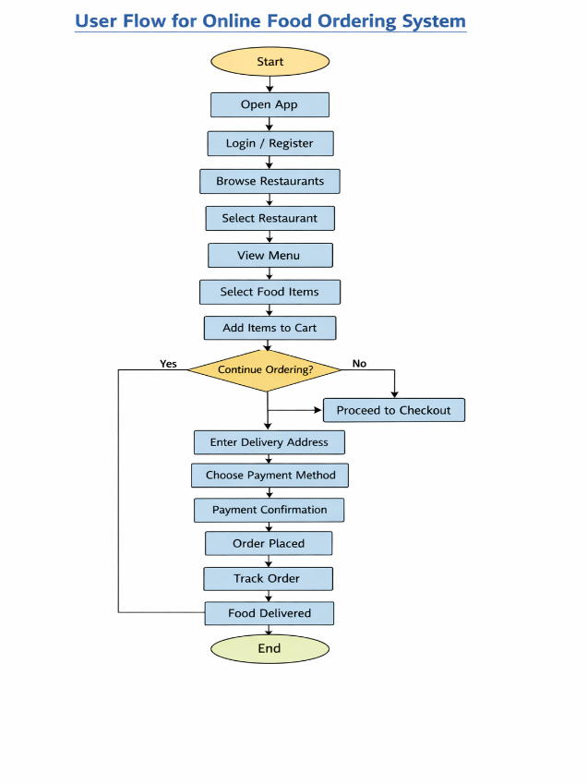
WireFrame

